# Use Case Diagram

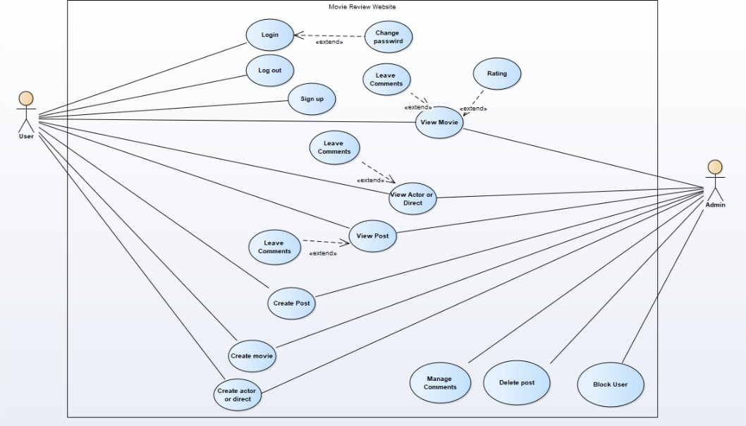

# Class Diagram

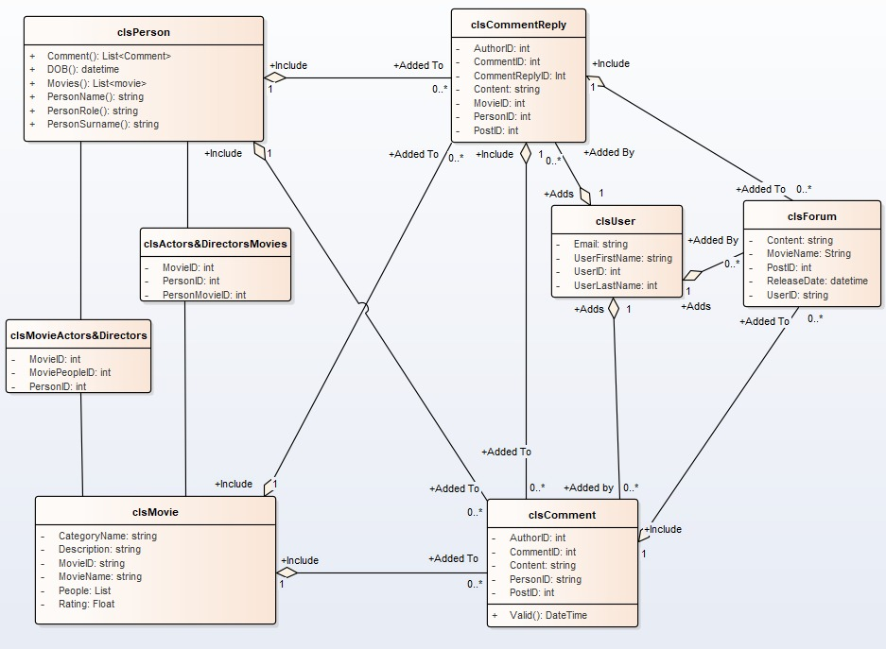

# Use Case Descriptions

## User – Sign-Up

|  |  |
| --- | --- |
| Use Case Name (Short two or three word name) | Sign Up |
| Use case Description | User Sign-Up |
| Precondition |  |
| Use Case Author(s) (Who wrote this) | Enio Hallulli |
| Actor(s) (Who does this) | User |
| Locations (Where does this happen) | Online |
| Primary pathway (What is the normal “happy path” for this use case?) | 1. User presses the sign-up button 2. System redirects to the sign-up page 3. User writes all the detail that need to be provided 4. User presses register 5. The account will be added in the system |
| Alternate pathways (What other paths are there that are not the “happy path”?) | 1. The user doesn’t insert acceptable email se gets error message 2. The user doesn’t insert correct password in the confirm password so gets error 3. The system crashes and reloads 4. The user inserts acceptable data 5. Account added in the system 6. The email inserted was already in use so need to insert a new one 7. The user inserts a new email 8. Account added in the system |
| Exception pathways (What could possibly go wrong?) | Account not added to the system  System crashes and reloads |

## User/admin – Log In

|  |  |
| --- | --- |
| Use Case Name (Short two or three word name) | Log In |
| Use case Description | User/admin Logs in |
| Precondition | User/admin is registered in the server |
| Use Case Author(s) (Who wrote this) | Enio Hallulli |
| Actor(s) (Who does this) | User |
| Locations (Where does this happen) | Online |
| Primary pathway (What is the normal “happy path” for this use case?) | 1. User/admin presses the log in button 2. System redirects to the log in page 3. User/Admin inserts log in information 4. User chooses if he wants to remember the details or not by ticking the remember square 5. System logs the user in the system |
| Alternate pathways (What other paths are there that are not the “happy path”?) | 1. User/Admin doesn’t insert acceptable data to log in so gets error 2. User/Admin doesn’t insert the wright password so gets error 3. User/Admin re-inserts acceptable data 4. System accepts data and logs in |
| Exception pathways (What could possibly go wrong?) | System doesn’t show the error and store the wrong data in the database  System crashes and reloads |

## User – Create post

|  |  |
| --- | --- |
| Use Case Name (Short two or three word name) | Create post |
| Use case Description | User create post |
| Precondition | User is registered and logged in |
| Use Case Author(s) (Who wrote this) | Enio Hallulli |
| Actor(s) (Who does this) | User |
| Locations (Where does this happen) | Online |
| Primary pathway (What is the normal “happy path” for this use case?) | 1. User select the forum button 2. System redirects to forum page 3. user presses create new 4. System redirects to the create new page 5. User inserts data in all fields 6. User presses create 7. The new post will be created and added in the forum page |
| Alternate pathways (What other paths are there that are not the “happy path”?) | 1. User Selects the forum button 2. System redirects to forum page 3. User presses create new 4. System redirects to the create new page 5. User doesn’t insert acceptable data on some fields 6. User presses create new 7. System doesn’t recognise the data and gives an error 8. The user Fixes the data 9. User presses create new again 10. System adds the new post |
| Exception pathways (What could possibly go wrong?) | System doesn’t show the error and store the wrong data in the database  User inserts wrong data  System crashes and reloads |

## User – Create Movie

|  |  |
| --- | --- |
| Use Case Name (Short two or three word name) | Create Movie |
| Use case Description | User create movie |
| Precondition | User is registered and logged in |
| Use Case Author(s) (Who wrote this) | Enio Hallulli |
| Actor(s) (Who does this) | User |
| Locations (Where does this happen) | Online |
| Primary pathway (What is the normal “happy path” for this use case?) | 1. User select the movies button 2. System redirects to movies page 3. User presses create new 4. System redirects to the create new page 5. User inserts data in all fields 6. User presses create 7. The new Movie will be created and added in the Movie page |
| Alternate pathways (What other paths are there that are not the “happy path”?) | 1. User Selects the movies button 2. System redirects to movies page 3. User presses create new 4. System redirects to the create new page 5. User doesn’t insert acceptable data on some fields 6. User presses create new 7. System doesn’t recognise the data and gives an error 8. The user Fixes the data 9. User presses create new again 10. System adds the new post |
| Exception pathways (What could possibly go wrong?) | System doesn’t show the error and store the wrong data in the database  User inserts wrong data  System crashes and reloads |

## User – Create Actors&Directors

|  |  |
| --- | --- |
| Use Case Name (Short two or three word name) | Create Actors&Directors |
| Use case Description | User create Actors&Directors |
| Precondition | User is registered and logged in |
| Use Case Author(s) (Who wrote this) | Enio Hallulli |
| Actor(s) (Who does this) | User |
| Locations (Where does this happen) | Online |
| Primary pathway (What is the normal “happy path” for this use case?) | 1. User select the Actors&Directors button 2. System redirects to Actors&Directors page 3. User presses create new 4. System redirects to the create new Actors&Directors page 5. User inserts data in all fields 6. User presses create 7. The new Actors or Directors will be created and added in the Actors&Directors page |
| Alternate pathways (What other paths are there that are not the “happy path”?) | 1. User Selects the Actors&Directors button 2. System redirects to Actors&Directors page 3. User presses create new 4. System redirects to the create new Actors&Directors page 5. User doesn’t insert acceptable data on some fields 6. User presses create new 7. System doesn’t recognise the data and gives an error 8. The user Fixes the data 9. User presses create new again 10. System adds the new post |
| Exception pathways (What could possibly go wrong?) | System doesn’t show the error and store the wrong data in the database  User inserts wrong data  System crashes and reloads |

## User – View Movie

|  |  |
| --- | --- |
| Use Case Name (Short two or three word name) | View Movie |
| Use case Description | User view movie |
| Precondition |  |
| Use Case Author(s) (Who wrote this) | Enio Hallulli |
| Actor(s) (Who does this) | User |
| Locations (Where does this happen) | Online |
| Primary pathway (What is the normal “happy path” for this use case?) | 1. User select the movies button 2. System redirects to movies page 3. User presses the name of the movie 4. System redirects to the movie details page 5. User can see the movie details and can even select an actor to see his details |
| Alternate pathways (What other paths are there that are not the “happy path”?) |  |
| Exception pathways (What could possibly go wrong?) | System crashes and reloads  System doesn’t recognise the selected movie |

## User – View Actors&Directors

|  |  |
| --- | --- |
| Use Case Name (Short two or three word name) | View Actors&Directors |
| Use case Description | User view Actors&Directors |
| Precondition |  |
| Use Case Author(s) (Who wrote this) | Enio Hallulli |
| Actor(s) (Who does this) | User |
| Locations (Where does this happen) | Online |
| Primary pathway (What is the normal “happy path” for this use case?) | 1. User select the Actors&Directors button 2. System redirects to Actors&Directors page 3. User presses the name of the Actors or Directors 4. System redirects to the Actors&Directors details page 5. User can see the Actors or Directors details and can even select the movie to see details |
| Alternate pathways (What other paths are there that are not the “happy path”?) |  |
| Exception pathways (What could possibly go wrong?) | System crashes and reloads  System doesn’t recognise the selected Actors&Directors |

## User/Admin – Leave Comment

|  |  |
| --- | --- |
| Use Case Name (Short two or three word name) | Leave Comment |
| Use case Description | User/Admin Leave Comment |
| Precondition | Logged in |
| Use Case Author(s) (Who wrote this) | Enio Hallulli |
| Actor(s) (Who does this) | User/Admin |
| Locations (Where does this happen) | Online |
| Primary pathway (What is the normal “happy path” for this use case?) | 1. User/Admin select the Actors&Directors/Movies/Forum page button 2. System redirects to selected page 3. User/Admin presses Comment 4. User/admin insert the content 5. User admin press comment 6. Comment added to the system |
| Alternate pathways (What other paths are there that are not the “happy path”?) |  |
| Exception pathways (What could possibly go wrong?) | System crashes and reloads  System doesn’t recognise the selected Actors&Directors |

## Admin – Manage Comments

|  |  |
| --- | --- |
| Use Case Name (Short two or three word name) | Manage comments |
| Use case Description | Admin Manage Comments |
| Precondition | Admin logged in |
| Use Case Author(s) (Who wrote this) | Enio Hallulli |
| Actor(s) (Who does this) | Admin |
| Locations (Where does this happen) | Online |
| Primary pathway (What is the normal “happy path” for this use case?) | 1. Admin selects manage comments 2. The system shows all the comments 3. Admin decide what to do:  * Delete Comment * Modify Comment * Block User  1. System ask if it is sure or not 2. Admin accepts or declines 3. In that case it can:  * Delete * Modify * Block |
| Alternate pathways (What other paths are there that are not the “happy path”?) | 1. Admin selects manage comments 2. The system shows all the comments 3. Admin doesn’t choose anything, and presses delete or modify 4. The system returns error message 5. Admin choose the right thing 6. System modify, deletes or block |
| Exception pathways (What could possibly go wrong?) | System fails to redirect to delete or modify page  System crashes and reloads |

## Admin – Manage the post

|  |  |
| --- | --- |
| Use Case Name (Short two or three word name) | Manage the post |
| Use case Description | Admin Manage the post |
| Precondition | Admin logged in |
| Use Case Author(s) (Who wrote this) | Enio Hallulli |
| Actor(s) (Who does this) | Admin |
| Locations (Where does this happen) | Online |
| Primary pathway (What is the normal “happy path” for this use case?) | 1. Admin selects manage comments 2. The system shows all the comments 3. Admin decide what to do:  * Delete Comment * Modify Comment * Block User  1. System ask if it is sure or not 2. Admin accepts or declines 3. In that case it can:  * Delete * Modify  1. Block |
| Alternate pathways (What other paths are there that are not the “happy path”?) | 1. Admin selects manage comments 2. The system shows all the comments 3. Admin doesn’t choose anything, and presses delete or modify 4. The system returns error message 5. Admin choose the right thing 6. System modify, deletes or block |
| Exception pathways (What could possibly go wrong?) | Film is not added to the list of films  System crashes |

## Admin – Block User

|  |  |
| --- | --- |
| Use Case Name (Short two or three word name) | Block the user |
| Use case Description | Admin block users |
| Precondition | Admin logged in |
| Use Case Author(s) (Who wrote this) | Enio Hallulli |
| Actor(s) (Who does this) | Admin |
| Locations (Where does this happen) | Online |
| Primary pathway (What is the normal “happy path” for this use case?) | 1. Admin selects the ID of the user he wants to ban 2. Admin goes to the ban page 3. Admin enters the fields of the user that need to be banned 4. Admin press the ban button 5. The system will ban the user and all his posts |
| Alternate pathways (What other paths are there that are not the “happy path”?) | 1. Admin selects the ID of the user he wants to ban 2. Admin goes to the ban page 3. Admin enters wrong data in the fields of the user that need to be banned 4. Admin presses the ban button 5. The system shows an error 6. Admin fixes the data 7. Admin press the ban button 8. The system will ban the user and all his posts |
| Exception pathways (What could possibly go wrong?) | The system won’t ban the user  The system will ban the user but won’t delete his posts  The system will ban the user and delete some posts but not all of them  System crashes and reloads |